**Supplementary information**

**Common agronomic adaptation strategies to climate change may increase soil greenhouse gas emission in Northern Europe**

Diego Grados1*, David Kraus2, Edwin Haas2, Klaus Butterbach-Bahl2,3, Jørgen Eivind Olesen1, Diego Abalos1

*1 Department of Agroecology, iClimate, Aarhus University, 8830 Tjele, Denmark*

*2 Institute of Meteorology and Climate Research, Atmospheric Environmental Research, Karlsruhe Institute of Technology, 82467 Garmisch-Partenkirchen, Germany*

*3 Pioneer Center Land-CRAFT, Department of Agroecology, Aarhus University, 8000 Aarhus C, Denmark*

*Correspondence: [diegogradosb@agro.au.dk](mailto:diegogradosb@agro.au.dk)

**Number of pages:** 8

**Number of figures:** 6

**Number of tables:** 3

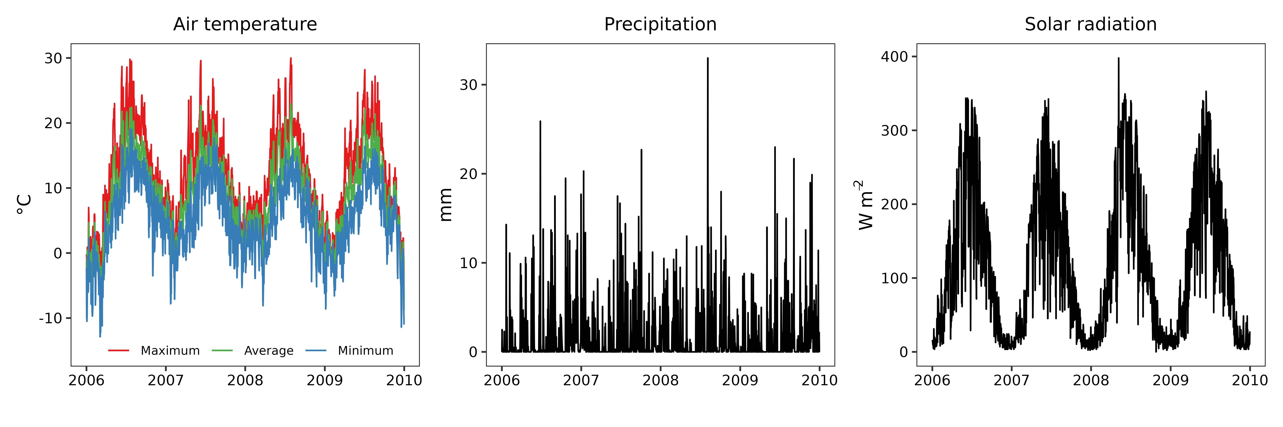

**Figure S1.** Daily climate variables (2006-2009) during the field experiment.

**Table S1**. List of coupled Global Circulation and Regional Climate Models used in the scenarios evaluation.

|  |  |
| --- | --- |
| **Global Circulation Model** | **Regional Climate Model** |
| CNRM-CERFACS-CNRM-CM5 | CNRM-ALADIN63 |
| ICHEC-EC-EARTH | CLMcom-CCLM4-8-17 |
| MOHC-HadGEM2-ES | SMHI-RCA4 |
| MPI-M-MPI-ESM-LR | MPI-CSC-REMO2009 |
| NCC-NorESM1-M | DMI-HIRHAM5 |

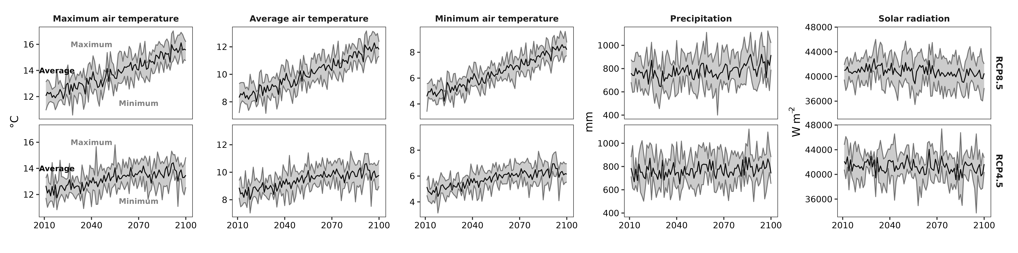

**Figure S2.** Monthly climate variables (2010-2100) aggregated from the coupled Global Circulation and Regional Climate Models used in the scenarios evaluation. The black line represents the average value and the gray area the maximum and minimum values.

**Table S2**. Initial soil physicochemical characteristics of the long-term experiment for the simulations.

|  |  |  |  |  |  |  |  |  |  |  |
| --- | --- | --- | --- | --- | --- | --- | --- | --- | --- | --- |
| **layer** | **pH** | **bulk density** | **total nitrogen** | **total carbon** | **clay content** | **sand content** | **silt content** | **field capacity** | **wilting point** | **saturated hydraulic conductivity** |
| **(cm)** |  | **(kg dm-3)** | **(%)** | **(%)** | **(kg kg-1)** | **(kg kg-1)** | **(kg kg-1)** | **(dm3 m-3)** | **(dm3 m-3)** | **(cm min-1)** |
| 0-25 | 6.5 | 1.42 | 0.151a | 1.96b | 8.8 | 60.3 | 27.2 | 302.7 | 65.8 | 0.0175 |
| 25-50 | 5.9 | 1.48 | 0.094 | 1.25 | 11.2 | 58.9 | 27.8 | 302.7c | 77.9 | 0.0112 |
| 50-75 | 5.2 | 1.73 | 0.041 | 0.43 | 13.5 | 58.7 | 27.0 | 263.0 | 80.8 | 0.0019 |
| 75-100 | 4.8 | 1.78 | 0.026 | 0.21 | 14.4 | 59.1 | 26.0 | 224.1 | 61.9 | 0.0016 |

a Value was decreased from 0.175 % to 0.151 % (based on the standard deviation) to better simulate the total soil nitrogen content.

b Value was decreased from 2.29 % to 1.96 % (based on the standard deviation) to better simulate the soil organic carbon content.

c Value was increased from 257.7 dm3 m-3 to 302.7 dm3 m-3 (based on the standard deviation) to better simulate the soil moisture content.

**Table S3**. Goodness-of-fit statistics for the model performance ($MAE$: mean absolute error, $RMSE$: root mean square error, ${RMSE}_{s}$: systematic $RMSE$, ${RMSE}_{u}$: unsystematic $RMSE$, $d_{r}$: redefined index of agreement).

|  |  |  |  |  |  |  |  |  |  |
| --- | --- | --- | --- | --- | --- | --- | --- | --- | --- |
|  |  |  | **Observations** | | **Summary statistics** | | | | |
| **Variable** | | **Units** | ***n***a | **Measurementb** |  |  |  |  |  |
| Yield | Potato | t DW ha-1 | 8 | 9.18 ± 2.24 | 1.89 | 2.12 | 2.02 | 0.64 | 0.51 |
| Winter wheat | 8 | 7.90 ± 1.10 | 1.20 | 1.36 | 1.26 | 0.52 | 0.33 |
| Spring barley | 8 | 5.37 ± 0.53 | 1.54 | 1.72 | 1.43 | 0.95 | -0.46 |
| Faba bean | 6 | 3.22 ± 0.77 | 0.93 | 1.15 | 1.15 | 0.14 | 0.28 |
| Yield nitrogen uptake | Potato | kg N ha-1 | 8 | 131.90 ± 21.46 | 14.19 | 16.41 | 15.32 | 5.90 | 0.62 |
| Winter wheat | 8 | 153.46 ± 19.18 | 17.40 | 20.68 | 18.73 | 8.77 | 0.41 |
| Spring barley | 8 | 97.11 ± 11.02 | 24.14 | 26.15 | 6.50 | 25.33 | -0.26 |
| Faba bean | 6 | 162.24 ± 35.96 | 49.52 | 59.07 | 58.70 | 6.62 | 0.17 |
| Soil | Temperature | °C | 112 | 9.32 ± 4.60 | 0.89 | 1.14 | 0.44 | 1.06 | 0.89 |
| Volumetric moisture | % | 112 | 24.80 ± 5.69 | 0.62 | 0.83 | 0.12 | 0.82 | 0.93 |
| Organic carbon | t C ha-1 | 16 | 47.68 ± 9.07 | 8.18 | 10.36 | 10.35 | 0.49 | 0.50 |
| Total nitrogen | t N ha-1 | 16 | 3.68 ± 0.59 | 0.49 | 0.67 | 0.66 | 0.03 | 0.48 |
| Nitrous oxide | g N2O-N ha-1 d-1 | 371 | 3.35 ± 5.29 | 4.44 | 10.75 | 0.89 | 10.71 | 0.38 |
| a Number of observed-simulated pairs. | | | | | | | | | |
| b Values represent mean ± standard deviation for each measurement. | | | | | | | | | |

**Figure S3.** Observed and simulated values of the yield (Panel A) and yield nitrogen uptake (Panel B) throughout the growing seasons in the long-term field experiment.

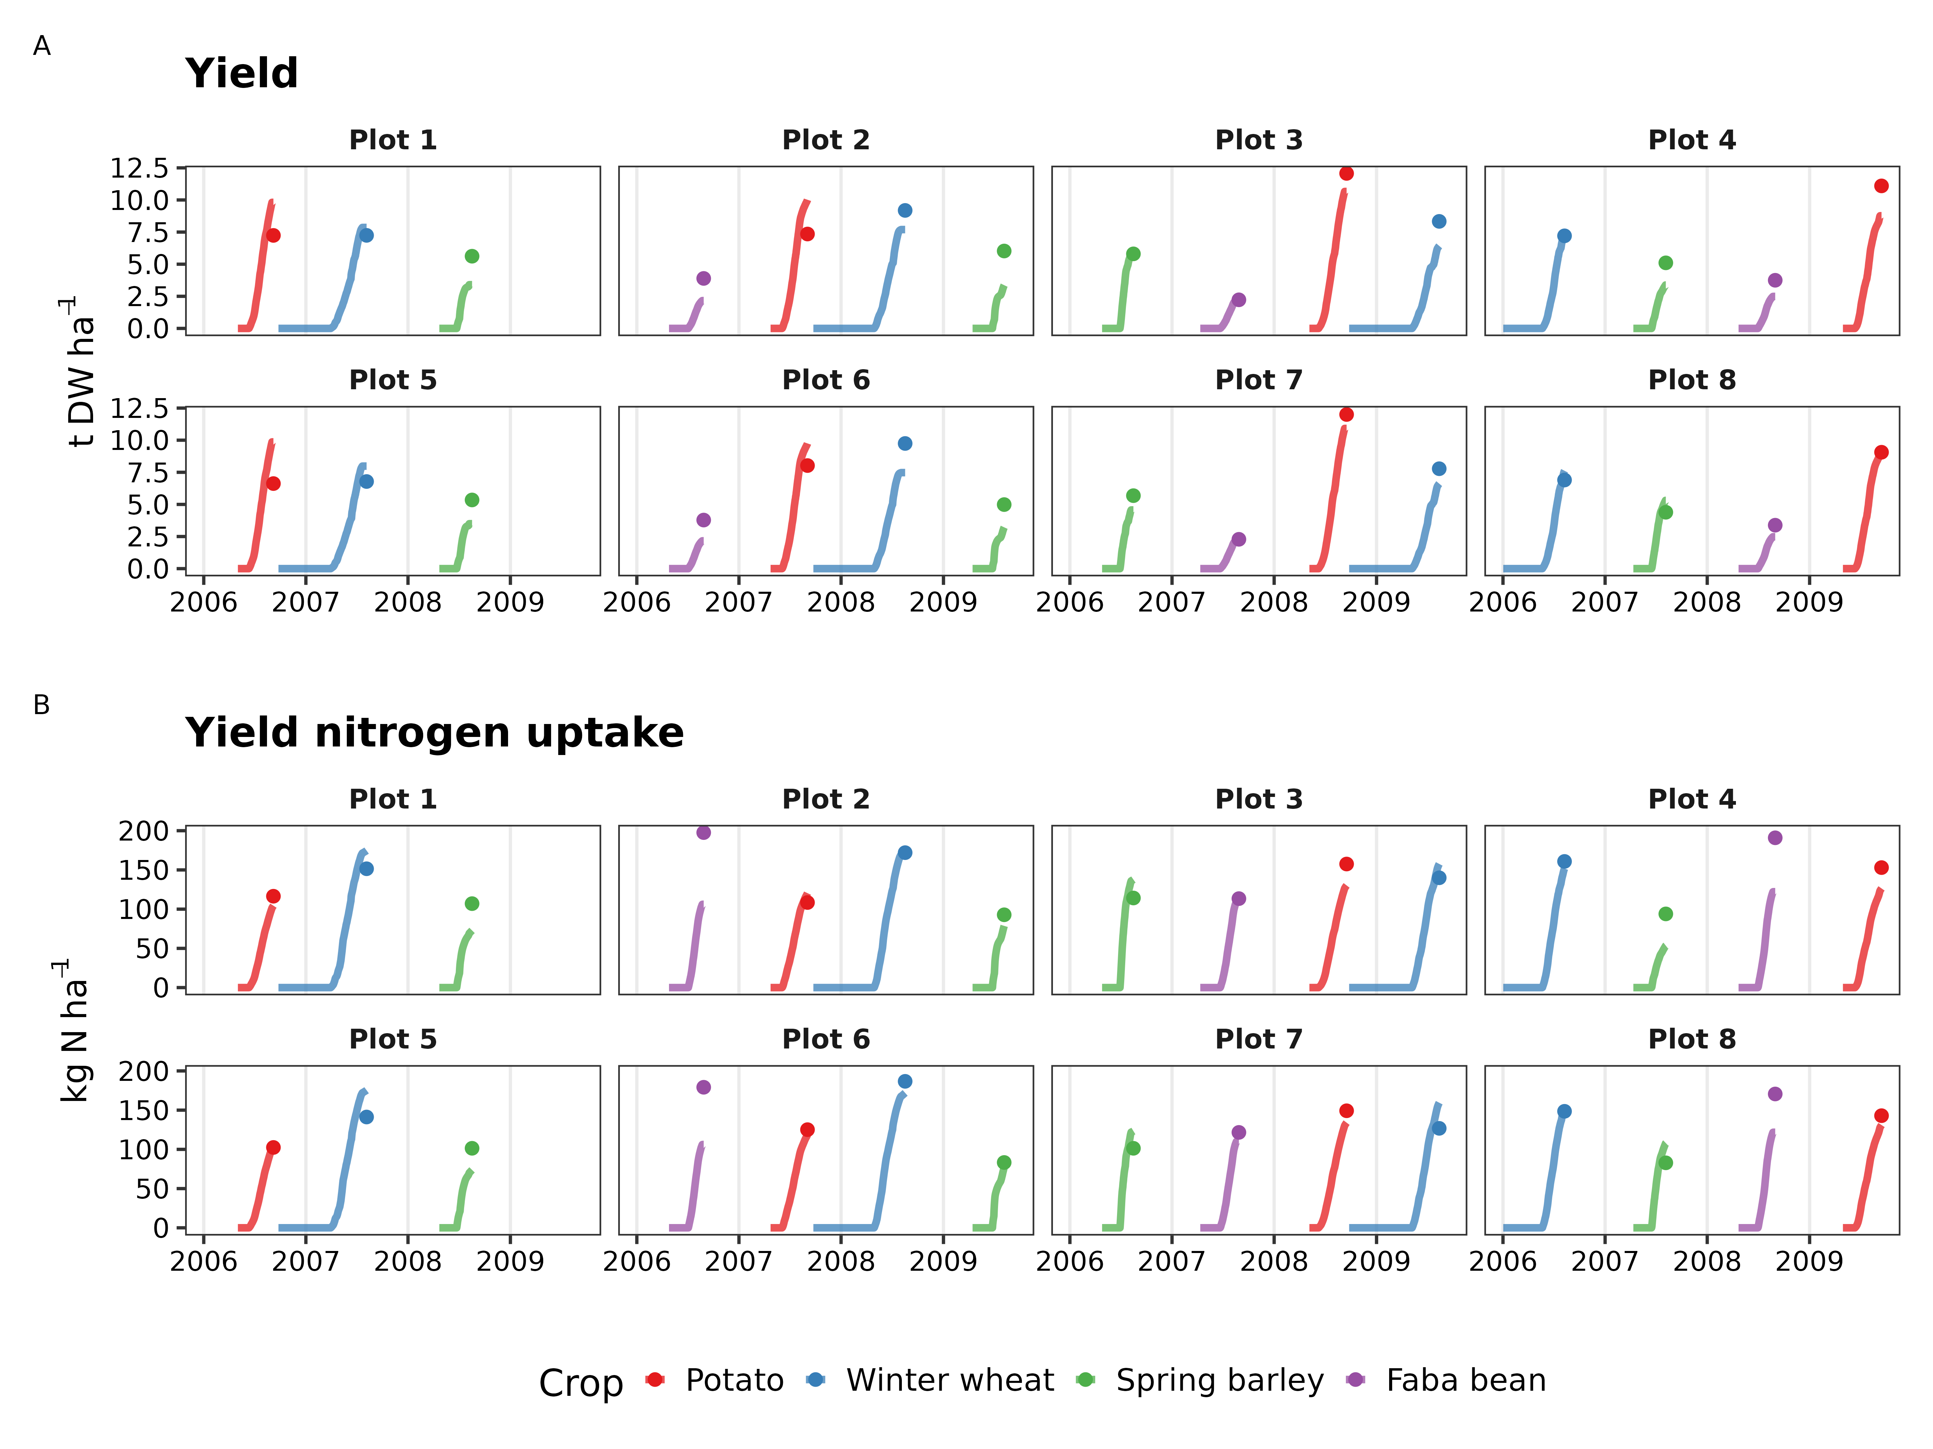

**Figure S4.** Observed and simulated values of the soil temperature (Panel A) and soil moisture (Panel B) throughout the growing seasons in the long-term field experiment.

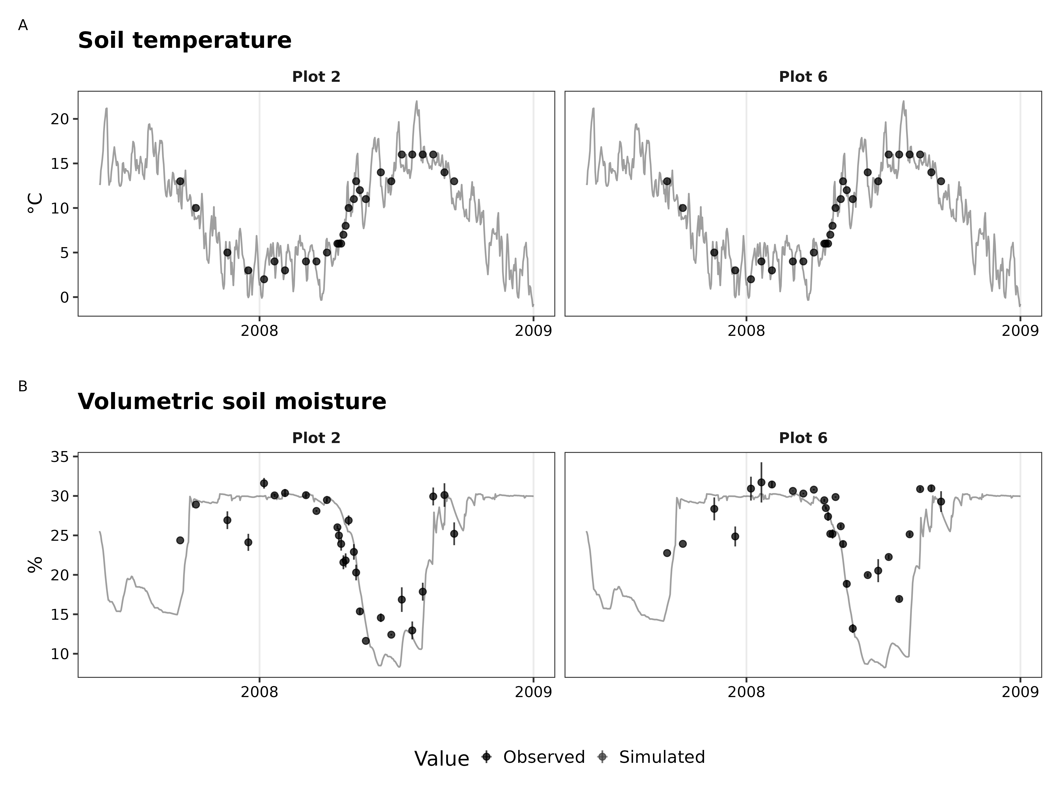

**Figure S5.** Observed and simulated values of the soil organic carbon (Panel A) and total nitrogen (Panel B) throughout the growing seasons in the long-term field experiment.

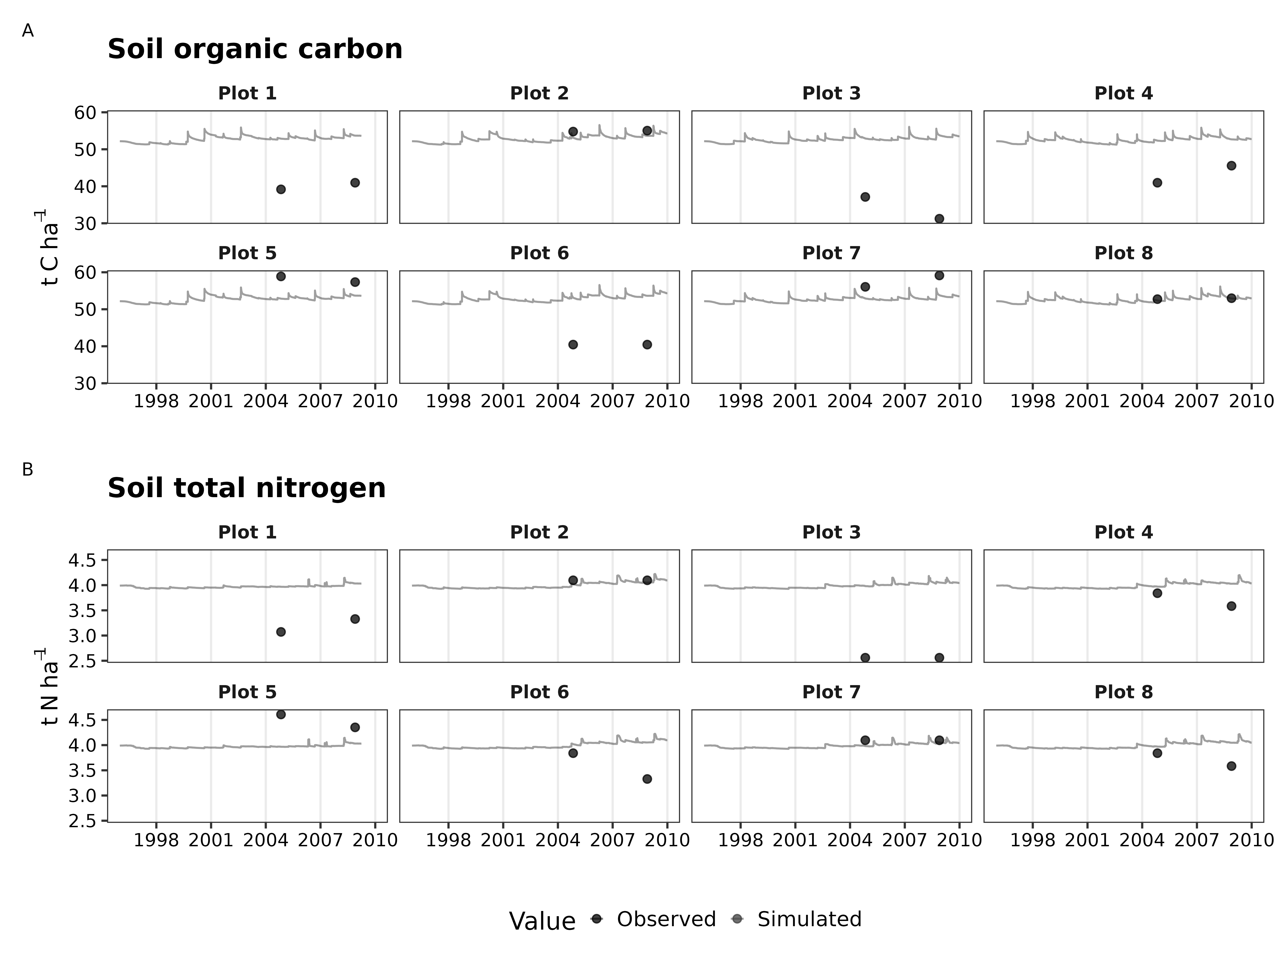

**Figure S6.** Observed and simulated values of nitrous oxide emissions throughout the growing seasons in the long-term field experiment.

